DISEASES OF THE MUZZLE
1)The congenital defect of harelip, cleft palate.
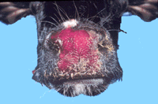
2) dermatitis with scab formation, development of fissures, and sloughing and gangrene of the skin of the muzzle. Cheilitis (inflammation of the lips).
common lesions in cattle affected with photosensitive dermatitis, bovine malignant catarrh, bovine virus diarrhea and rinderpest
In sheep bluetongue and ecthyma.

Stomatitis
Stomatitis is inflammation of the oral mucosa and includes glossitis (inflammation of the tongue), palatitis (Lampas)(inflammation of the palate) and gingivitis (inflammation of the mucosa of the gums).

Clinically Characterized By: - Partial or complete loss of appetite. smacking of the lips ,Profuse salivation.

ETIOLOGY: physical, chemical or infectious agents
A- Physical agents:
Trauma, Laceration of the tongue, Foreign body injury, Malocclusion of teeth, Sharp awns or spines on plants. abrasive feed, eating hairy caterpillars that infest Pasture, awn in barley cultivars used to make cattle silage fed in some regions , frozen feed ,and hot water.

B-Chemical agents:
1-Irritant drugs with overstrong concentrations, like chloral hydrate or formaline.
2-Counterirritants applied to skin, left unprotected and licked by the animal.
3- Irritant substances administered by mistake, including acids, alkalis and phenolic compounds .
4- systemic poisons e.g. chronic mercury poisoning. some fungi , uremia.

C- Infectious agents:
1- Bacterial stomatitis:
erosions to ulcers occur late in the stages of many oral diseases when secondary bacterial infection
Cattle | Sheep | Horse
1-Actinobacillosis : extend from jaw and ulcers on the dorsum and sides of the tongue and on the lips |  | Lingual abscess associated with Actinobacillus spp.

2- Oral Necrobacillosis associated with Fusobacterium necrophorum

3- Actinomycosis :

Ulcerative, granulomatous lesions may occur on the gums

2- Mycotic stomatitis:

in most infection with Monilia spp. a heavy white deposit with little inflammation or damage to the mucosa. some ulcers Secondary infection with fungi, and Granulomatous lesions due to sheep mycotic dermatitis.

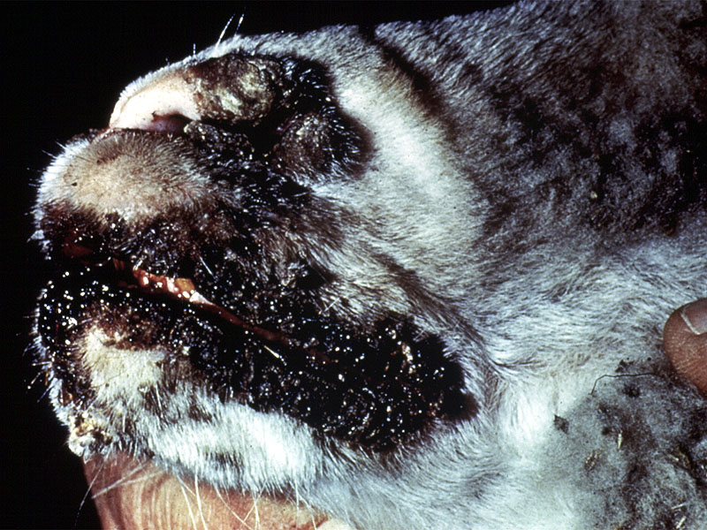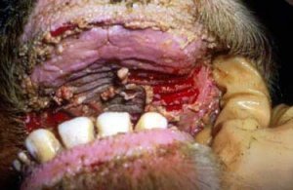

3- Viral stomatitis:
Cattle | Sheep | Horse
vesicles occurs in :  - foot-and-mouth disease  - vesicular stomatitis | Vesicular lesions rarely in foot and mouth disease | Vesicular lesions in vesicular stomatitis
Erosive, with some secondary ulcerative, stomatitis occurs in :  - bovine viral diarrhea (mucosal disease)  - bovine malignant catarrh  - rinderpest  - bluetongue. | Erosive lesions in:  - Bluetongue.  - rinderpest .  - peste de petits ruminantes. | Herpesvirus infections are small (1 mm diameter) vesicles surrounded by a zone of hyperemia. The lesions are in groups and then hemorrhages
Proliferative lesions occur in  - popular stomatitis  - proliferative stomatitis | Granulomatous lesions due to :  - ecthyma  - sheep pox  - ulcerative dermatosis  - coital exanthema

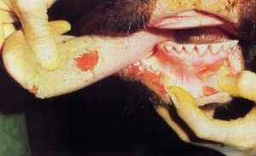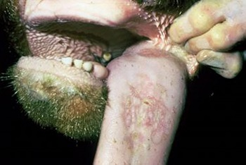

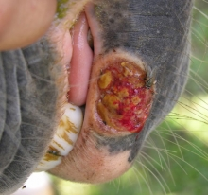

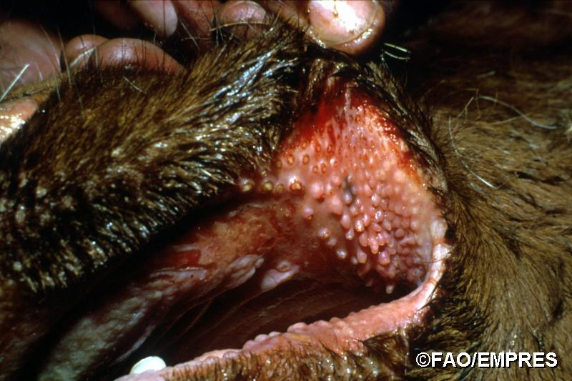

General Clinical Findings:
1- Partial or complete anorexia.
2- slow, painful mastication. and smacking of the lips.refuse examination of mouth .
4-Salivation may be frothy or profuse, and drools if the animal does not swallow normally. Saliva may contains pus or shreds of epithelial tissues
5- A fetid odor if bacterial invasion of the lesion has occurred.
6- Enlargement of local lymph nodes with swelling of the face in some cases where a cellulitis extends to involve soft tissues.
7- Increased desire for water.
8-lisions are :
a- Catarrhal stomatitis :is manifested by a diffuse inflammation of the buccal mucosa.
b- Traumatic lesions: the mucous membrane sloughing then heal of granulation tissue .
c- Erosions are shallow areas of necrosis commonly on the lingual mucosa then shed, leaving a dark red base that heal very quickly.
d- Ulcerative lesions penetrate more deeply painful, the tongue may be swollen . m.m suppuration and covered by yellow layer necrotic. Gangrene (bacterial infection)
e- Mycotic stomatitis is characterized by diffuse a heavy, white mucosa.Ulcerative lesions
f- Proliferative lesions abnormality raised above the surface of the mucous membrane as in oral papillomatosis.(viral infection)
g- Vesicles are thin-walled swellings 1-2 cm in diameter filled with clear serous fluid. They are very painful and rupture readily to leave sharp-edged, shallow ulcers. (viral infection)

TREATMENT:
1- Isolation of diseased animals which should be fed and watered from separate utensils.
2- Specific treatment is dealt with under the specific diseases.
3- non specific treatment includes:
a) Frequent application of a mild antiseptic solutions
such as:
- 2% sol. of copper sulphate.
- 2% suspension of borax.
- 1% suspension of sulphonamides in glycerin.
- 1 % suspension of acrifiavin in glycerin.
- 2% sol. of pot. chlorate or alum.
b) In ulcers diphtheroid lesions require curettage or cauterization with a silver nitrate stock or tincture of iodine (2.5%) in 10% glycerin.
c) There may be need in some cases to antibiotic application.
d)in all cases :soft food by stomch tube or I\V.

You have to repeat this treatment daily till complete recovery.

Diseases Of The Teeth: mostly surgery case .

Etiology
1) Congenital defects
2) Dental fluorosis,
3)Erosion of the enamel :(The feeding of acidic feed such as sweet potato, Feeding cattle with heavily compacted Silage)
4)Premature wear and loss of teeth in sheep (periodontal disease): Broken mouth is a chronic inflammatory disease of the tissue supports of the tooth by Bacteroides gingivalis .with inadequate dietary intake of copper or vitamin D as predisposing factor.

Clinical Findings
tooth movement, gum recession and pocketing Gingivitis is characterized by redness and edema of the attached gingiva. With Bleeding .Chronic gingivitis results in a downward retreat of the gum margin and formation of pockets.

Treatment And Control
There is no reliable treatment and control

DISEASES OF THE PAROTID SALIVARY GLANDS

Disease of the parotid gland includes parotitis which can be septic or associated with sialolithiasis, congenital abnormalities, neoplasia, and trauma
- Inflammation of the salivary glands (sialadenitis) can be secondary to sialolithiasis.

ETIOLOGY
  - The glandular tissue is diffusely inflamed, or it may be a local suppurative lesions( lymph node abscess. Neoplasia ,Trauma). There are no specific causes in farm animals.
- only sporadically invasion up the salivary ducts associated with stomatitis, irritation by grass awns in the duct, or salivary calculi. Avitaminosis a predisposing cause in cattle.
- Septic sialadenitis of horses: swelling of the parotid or submandibular salivary glands due to Sialoliths can form around foreign bodies, such as grass seeds or grains.
CLINICAL FINDINGS
Enlargement of the gland, pain on palpation, mastication and swallowing. local edema in
severe cases.

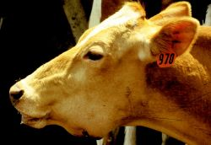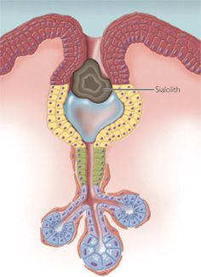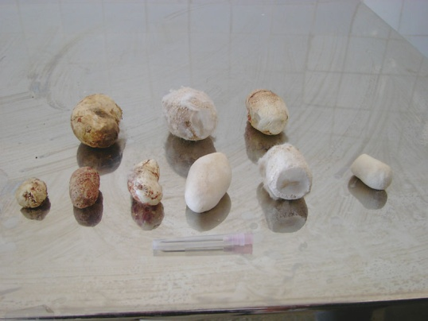
DIFFERENTIAL DIAGNOSIS
- lymphadenitis, abscesses of the throat region.
- parotid lymph node
- inflammation of the throat accompanied by high fever ,toxemia, and rapid death, pronounced obstruction to swallowing and respiration

TREATMENT
1)Systemic treatment with sulfonamides or Antibiotics.
2)Abscesses might require draining. ( salivary fistula is a common sequel).
3) sialoliths removal .

